Operating System Week 6-7

Name : Tanishq Vyas
SRN : PES1201800125
Section : H
Semester : 5
Branch : CSE

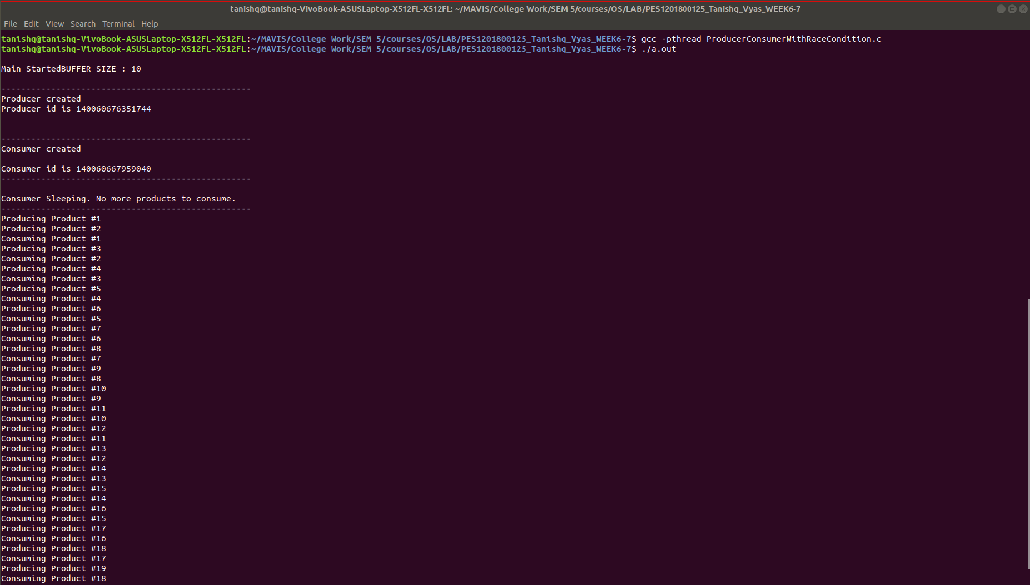
Fig : Execution for Producer-Consumer with Race Condition

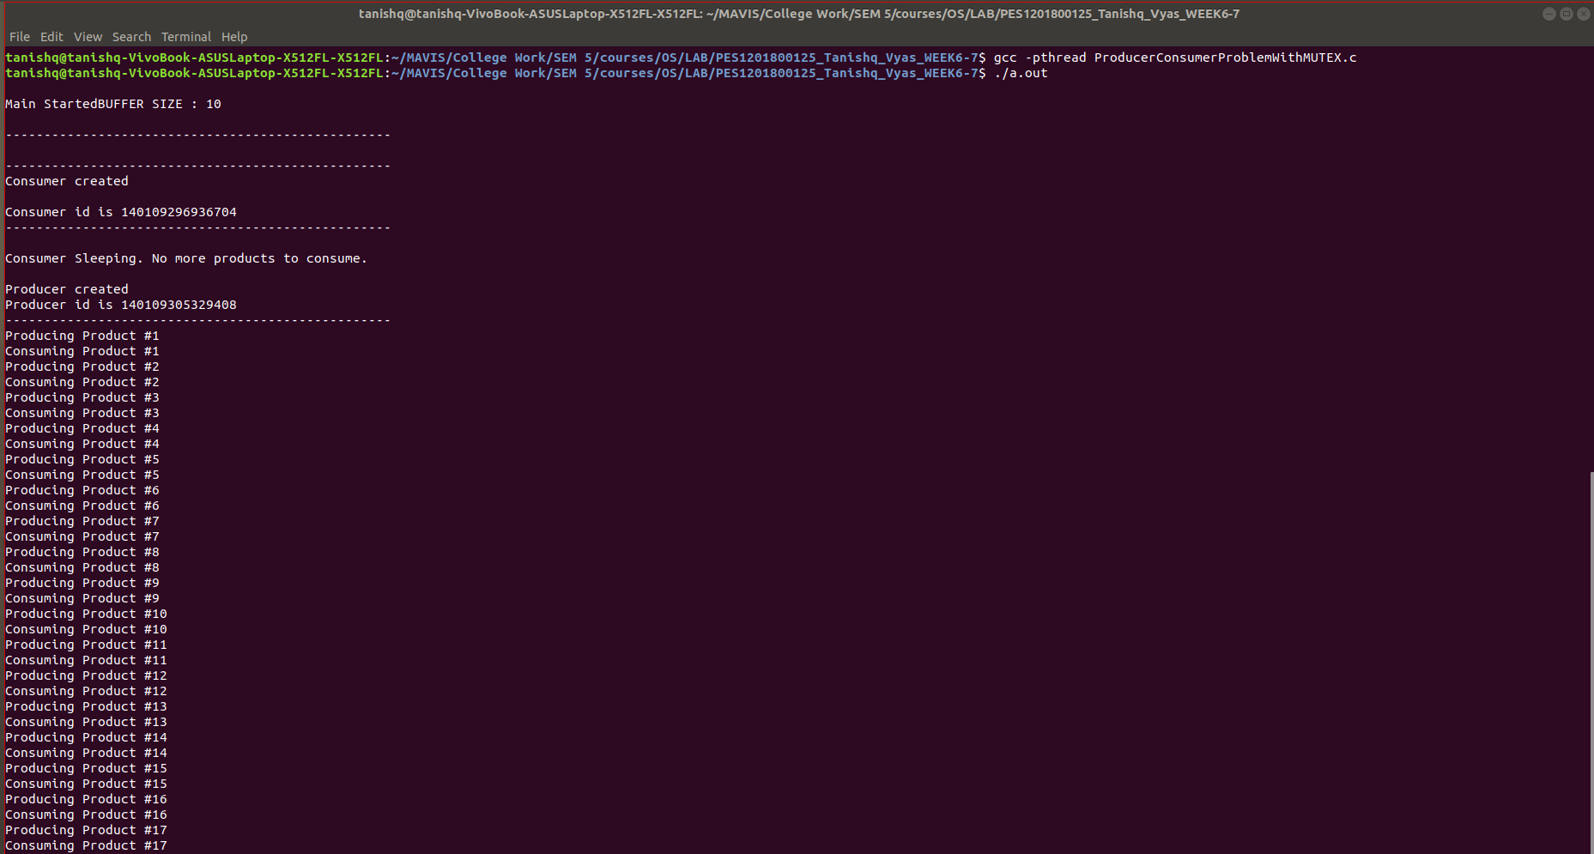
Fig : Execution for Producer-Consumer with MUTEX

